Balachandran, Ryan 2/17/2022
Course Number: PHYS.1410L
Section Number: 804
Instructor: Dr. Mittler
Partners(s): I don’t remember their names

Projectile Motion

Introduction

The simplest projectile motion consists of an object moving through the air under the influence of gravity only. Our study will be restricted to motion that is in two dimensions which results in parabolic trajectories but will also include the effects of air resistance.

Theory

In the absence of air resistance, the motion in the y-direction is determined by the acceleration due to gravity (g) and the motion in the x-direction is one of constant velocity as the acceleration in the x-direction is zero. These motions are independent but are connected through the time (t); i.e., the time needed to move through the air vertically is the same as the time needed to move horizontally. The kinematic equations for motion with constant acceleration may be applied to each component of the projectile’s motion.

A projectile with initial conditions; $t=0, initial speed=V_{0}, angle of projection= θ_{0}$ results in the following initial velocity components: $v_{0x}=v_{0}cosθ_{0} and v_{0y}=v_{0}sinθ_{0}$

The equations of linear motion (with constant acceleration) are:

$$v_{x}= v_{0x}+a_{x}t and v_{y}= v_{0y}+a_{y}t$$
$$x= x_{0}+v_{ox}t+\frac{1}{2}a_{x}t^{2} and y= y_{0}+v_{oy}t+\frac{1}{2}a_{y}t^{2}$$
$$v_{x}^{2}=v_{0x}^{2}+2a_{x}\left(x-x_{0}\right) and v_{y}^{2}=v_{0y}^{2}+2a_{y}\left(y-y_{0}\right)$$

Applying the conditions for projectile motion (accelerations $a_{x}=0 and a_{y}=-g$), these equations become:

$v_{x}=v_{0x}=constant$ $v_{y}= v_{0y}-gt$
$x= x_{0}+v_{0x}t$ $y= y_{0}+v_{0y}t-\frac{1}{2}gt^{2}$
$v_{y}^{2}=v_{0y}^{2}+2g\left(y-y_{0}\right)$

$y=\left(tanθ_{0}\right)x-\left(\frac{g}{2v_{0}^{2}\cos^{2}θ_{0}}\right)x^{2}$ (trajectory)
Using three of the equations above, we can use them to find the Max Height, Total Flight time, and Range (distance traveled).

- $v_{f}=v_{i}+at$
  - $at$ goes to zero, leaving the final velocity in the x-direction equal to the initial velocity in the x-direction

- $x_{f}=x_{i}+v_{i}t+\frac{1}{2}at^{2}$

- $v_{f}^{2}=v_{i}^{2}+2as$
  - $s=y_{f}-y_{i}$

Max Height: (3)

$$y_{0}=0 v_{of}=0$$

$$y_{max}=\frac{v_{o}^{2}\sin^{2}θ}{2g}$$

Total Time: (2)

$y_{0}=0$, solve quadratic equation for t = 0

$$T=\frac{2v_{0}sinθ}{g}$$

Range:
$$R= v_{0x}T=> \frac{v_{0}^{2}sin(2θ)}{g}$$
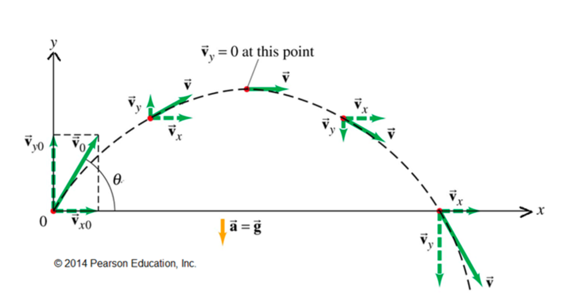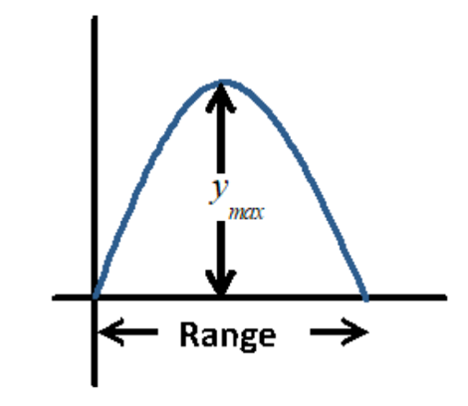

Apparatus and Procedure

Materials:
- Data studio folder
- Small metal ball
- Launcher
- Meter sticks
- Time-of-flight pad
- Carbon Paper
- White Paper

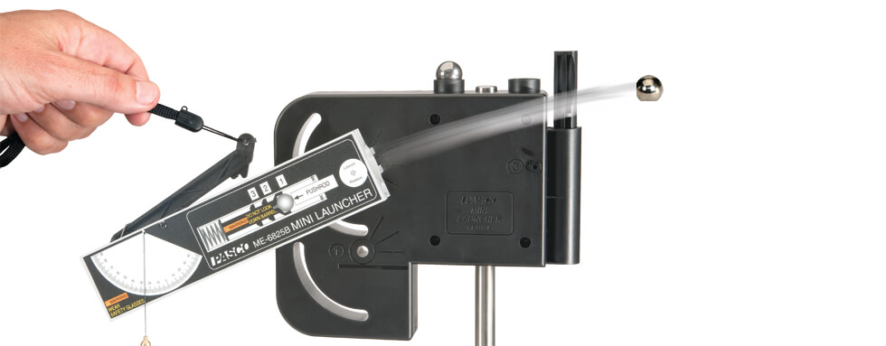
Launcher

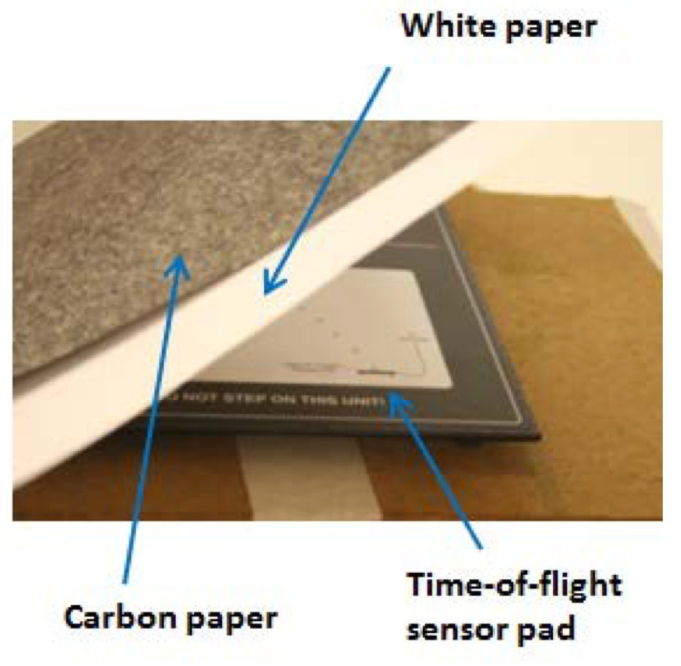
Procedure

This lab had three parts: 1) Initial speed of projectile, 2) Dependence on launch angle, and 3) Trajectory.

For the first part of the lab, was to take a small metal ball bearing and load it into the launcher using a plunger. The launcher has three speed settings, each with a click when loading the launcher. The first setting was the slowest and had one click when the metal ball was loaded with the plunger; the second had two clicks, and the third and fastest had three clicks. We took three measurements for each setting and averaged the results, with the third setting being used for the second part of the lab.

With the speed of the third setting averaged, we would then use a time-of-flight pad with both a white sheet of paper and a black sheet of carbon paper to mark where the ball lands after estimating its trajectory. With yard sticks, we would measure from the place the ball landed on the time-of-flight pad to the launcher as well as how high it went. We would take measurements from the time-of-flight pad given on the computer, distance the ball went, and its height for seven different angles of: 10, 20, 30, 45, 60, 70 and 80.

For the final part of the lab, we set the launcher to its first and slowest setting with a fixed angle against a gridded white board. We would then record the trajectory and place marks on the whiteboard every 5 cm.

Results and Data

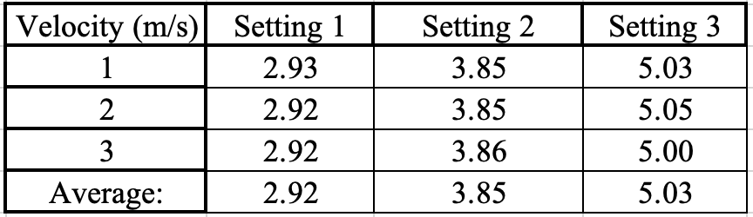
Part 1 results

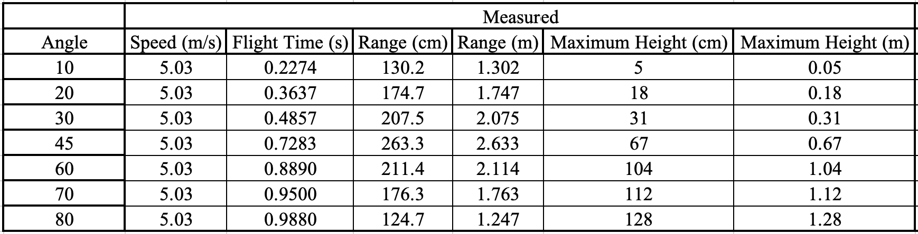
Part 2 (a)

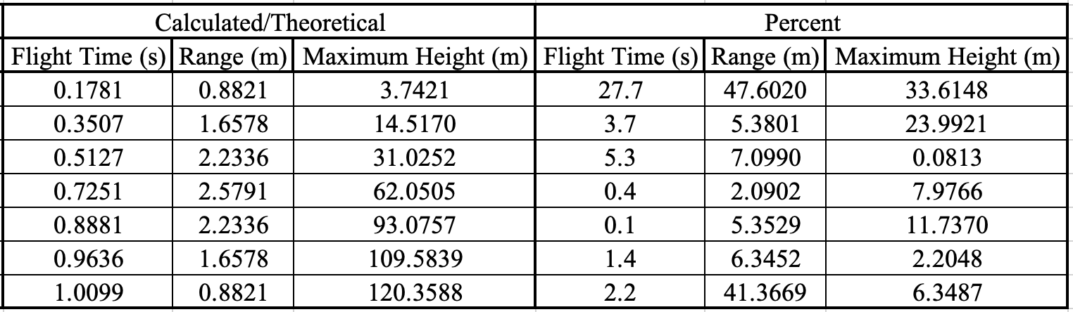
Part 2 (b)

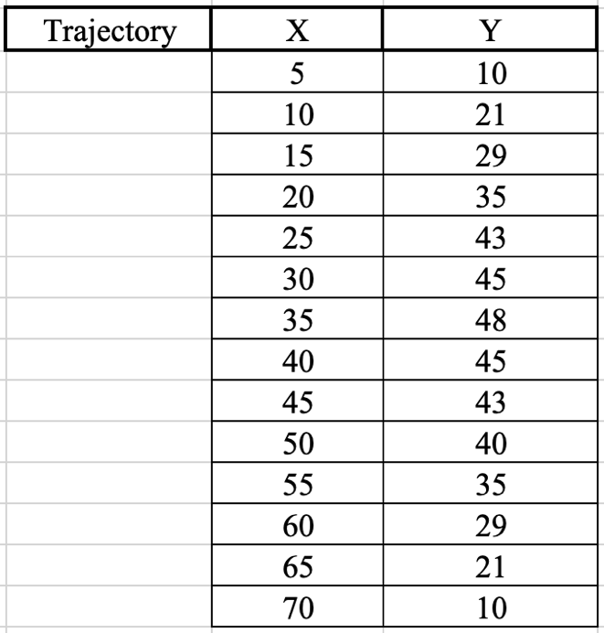
Part 3

Analysis
Calculations:

- Initial speed measurements were made by adding up the three values in one setting and dividing by 3 to get the average speed. Repeat for settings two and three.
  - Average speed for setting 1 is 2.92 m/s
  - Average speed for setting 2 is 3.85 m/s
  - Average speed for setting 3 is 5.03 m/s

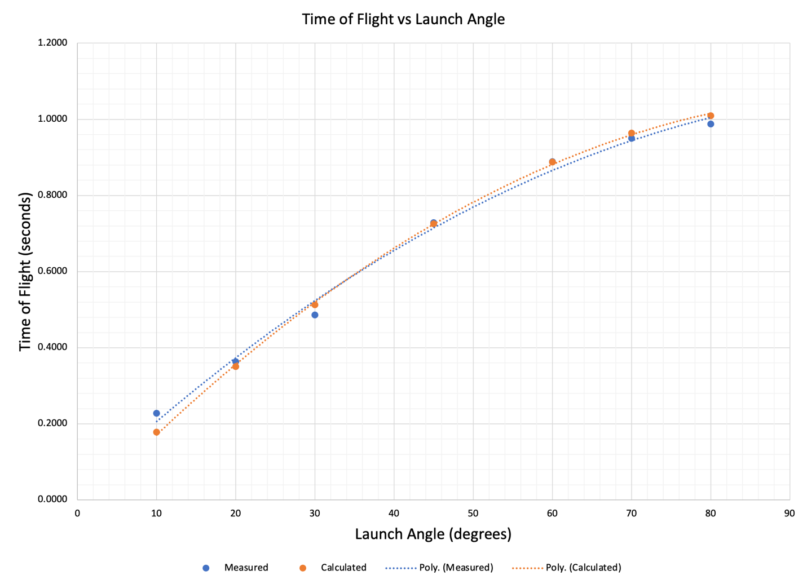
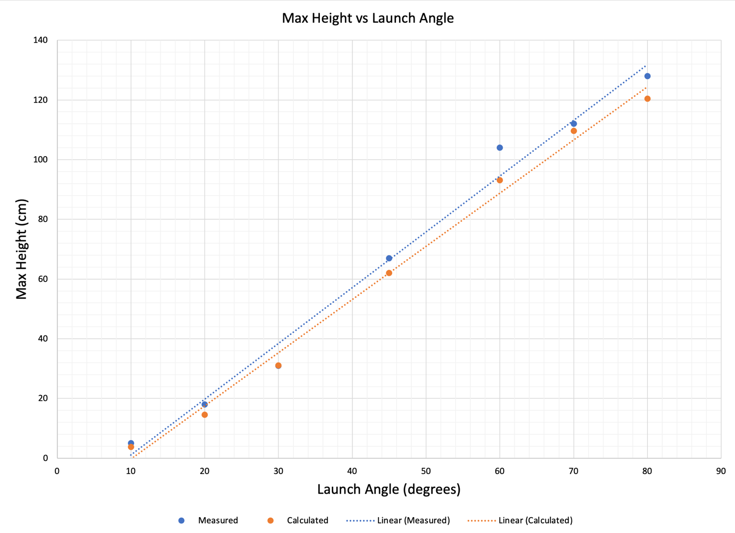

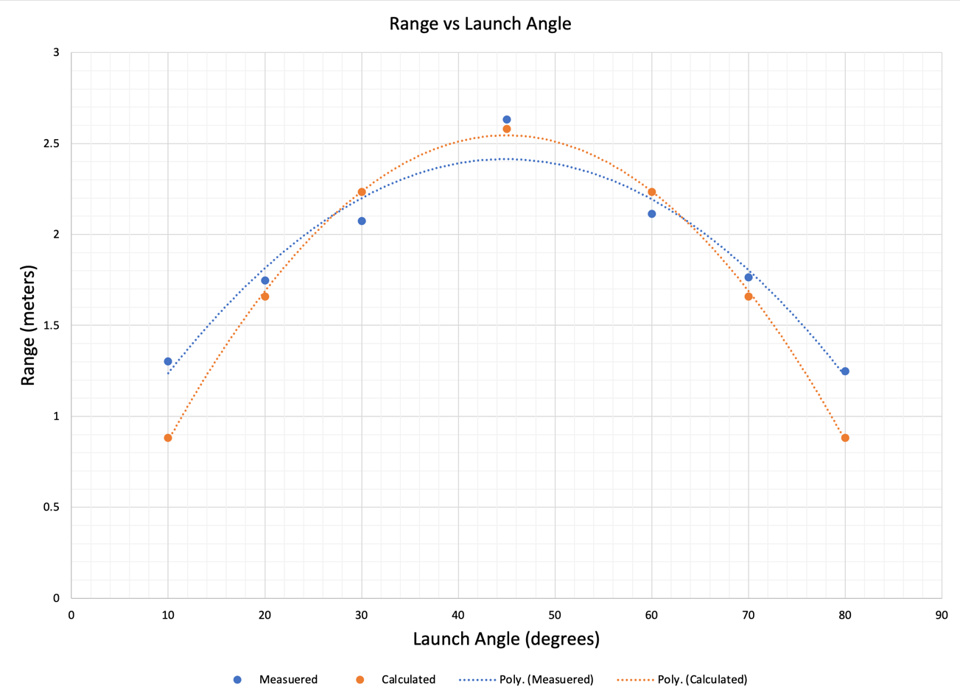
Discussion

The relation between the measured value and the calculated value for the three graphs of Time-of-Flight vs Launch Angle, Range vs Launch Angle, and Max Height vs Launch Angle is fairly close. According to the percent error calculated, the start and end values for range and max height were far apart, but the middle points were a lot more consistent.

When looking at the graph of Time-of-Flight vs Launch Angle, our measured values trended slightly lower compared to the calculated values. There were no discernable errors we could have made due to the fact the Time-of-Flight was calculated by the sensor pad connected to the computer.

When looking at the graph of Max Height vs Launch Angle, our measured values trended slightly higher than the calculated values. Any possible errors made in measurement would be due to not placing the meter stick exactly in the middle between the launcher and the time-of-flight sensor pad.

When looking at the graph of Range vs Launch Angle our measured values trended to have a lower arc compared to the calculated values. Any possible errors made in measurement would be due to any inaccuracies made in determining the distance from the launcher to the spot where the metal ball landed.

As for the Trajectory graph, I was not able to produce the calculated values to compare with the measured values.

Conclusion

Overall, the goal of the experiment was to study the effects of gravity on an object in two dimensions which results in a parabolic trajectory with the inclusion of air resistance. Comparing our measured values to the theoretical values when graphing Time of Flight vs Launch Angle, Max Height vs Launch Angle, and Range vs Launch Angle, we found them to be pretty consistent to what the actual values would be in an ideal situation.

Questions

I believe the diameter has the biggest effect on the range. When the diameter increases, there is more surface area for wind/air to push on, slowing the object down faster, while the smaller the object is, the less surface area is available to slow it down.
